
Mini Project Report

Dynamic Spatial–Temporal Graph Transformer
for EEG-Based Valence–Arousal Emotion Recognition on the DEAP Dataset
Course: ICE478
Course Title: Machine Learning
Section: 06
Group: 09
Course Instructor: Dr. Raihan Ul Islam

Team Members:
Name | ID
Tahsina Tabassum | 2023-1-50-002
Saima Akter Tisha | 2022-3-50-018
Fariya Ahmed Bhuiyan | 2022-3-50-009
Iftekhar Alam | 2019-2-57-039

Abstract
This report presents an EEG-based binary emotion recognition system built on the DEAP dataset, which contains 32-channel electroencephalogram recordings from 32 participants viewing 40 music-video clips each, labelled with self-reported valence, arousal, dominance, and liking scores. The project frames the task as two binary classification problems — high vs. low valence and high vs. low arousal — using a threshold of 5.0 on the 1–9 rating scale. Signals are segmented into 4-second sliding windows (50% overlap) and represented in two complementary domains: a normalized raw time-series branch and a five-band spectral power branch (theta, alpha, low-beta, high-beta, gamma). A custom architecture, the Time-Efficient Dynamic Spatial-Temporal Graph Transformer (TEDSTGT), fuses these two views per electrode, builds a learned sparse functional connectivity graph biased by the electrodes' physical layout, propagates information across electrodes with graph message-passing layers, and pools the result with an attention mechanism before separate valence and arousal classification heads. The model is lightweight (49,366 trainable parameters) and fast at inference (well under 1 millisecond per sample). Evaluated on a strictly subject-independent test split (7 held-out subjects, 8,120 windows), the model reached 76.4% accuracy on valence and 74.3% on arousal. However, macro-F1 scores (0.435 and 0.426) and ROC-AUC values (0.585 and 0.503) show that these accuracy figures are driven almost entirely by the model defaulting to the majority "Low" class rather than by genuine discriminative learning, a finding that is discussed in detail together with its causes and implications for future iterations of the project.

1. Introduction
Recognizing human emotion directly from brain activity is one of the central problems in affective computing and brain-computer interfaces. Unlike facial expressions or speech, electroencephalogram (EEG) signals are difficult to consciously mask, which makes them an attractive modality for objective emotion assessment, with applications ranging from mental-health monitoring to adaptive entertainment and human-computer interaction. At the same time, EEG-based emotion recognition is notoriously difficult: the signal-to-noise ratio is low, emotional responses vary substantially between individuals, and self-reported affect labels are inherently noisy.
This project (Group 9, Dataset 3) develops and evaluates a deep learning pipeline for binary valence and arousal classification using the DEAP dataset, a well-established benchmark in this field. The objective was to design a model that is spatially aware — i.e., one that can exploit the known geometry of the electrode montage and learn which electrodes communicate during an emotional response — while remaining computationally light enough to train and run inference quickly. The resulting architecture is referred to throughout this report as TEDSTGT (Time-Efficient Dynamic Spatial-Temporal Graph Transformer).

1.1 Objectives
- Build a reproducible preprocessing and feature-extraction pipeline that converts raw multi-subject DEAP recordings into windowed raw and spectral representations suitable for deep learning.
- Design a dual-domain (raw + spectral) neural architecture that models inter-electrode relationships through a dynamic, spatially-biased graph.
- Train the model to jointly predict binarized valence and arousal, evaluating on a subject-independent split to obtain a realistic estimate of generalization.
- Characterize the resulting model in terms of predictive performance, class-wise behaviour, interpretability (learned connectivity graph and electrode attention), and computational efficiency.
- Critically assess the limitations of the current results and identify concrete next steps.

2. Dataset
The project uses the DEAP dataset (Database for Emotion Analysis using Physiological Signals), obtained via the Kaggle mirror “manh123df/deap-dataset”. The dataset contains pre-processed, downsampled recordings for 32 participants, each of whom watched 40 one-minute music-video excerpts while 32-channel EEG (plus peripheral physiological signals, not used here) was recorded. After loading, each subject file was confirmed to contain a data array of shape (40 trials, 40 channels, 8,064 samples) and a labels array of shape (40 trials, 4 ratings), matching the documented DEAP format.

2.1 Signal and Label Properties
- Sampling rate: 128 Hz (pre-processed/downsampled DEAP release).
- Channels used: the first 32 channels, corresponding to the standard EEG montage (peripheral channels 33–40 were excluded).
- Trial length: 8,064 samples per trial (63 s), of which the first 3 s (384 samples) is a pre-stimulus baseline and was discarded before feature extraction.
- Labels: continuous self-assessment scores in the range 1–9 for valence, arousal, dominance, and liking. No missing values (NaNs) were found in either the signal or label arrays for any subject.
Because this project targets binary classification, valence and arousal ratings were binarized at a threshold of 5.0 (rating ≥ 5 → “High”, otherwise “Low”). At the trial level (1,280 trials = 32 subjects × 40 trials), this produced a valence split of 995 Low / 285 High and an arousal split of 965 Low / 315 High — an imbalance of roughly 78% / 22% for both targets. This imbalance persisted after windowing (see Section 3) and is a central factor in the results discussed in Section 5.
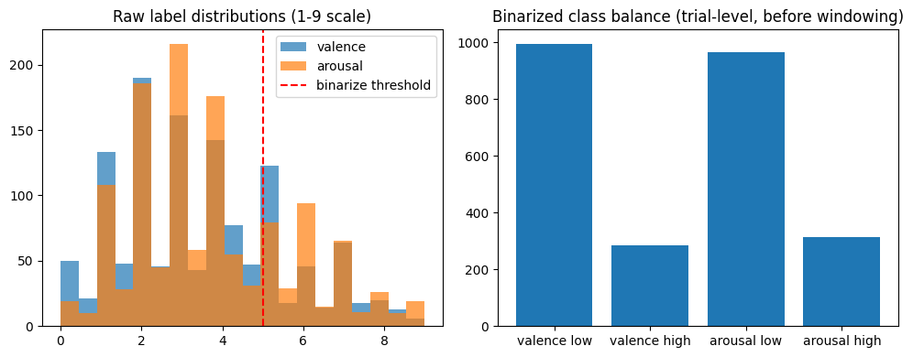
Figure 1. Left: distribution of raw 1–9 valence and arousal ratings with the binarization threshold marked. Right: resulting class balance at the trial level, showing the ≈78/22 imbalance in both targets.
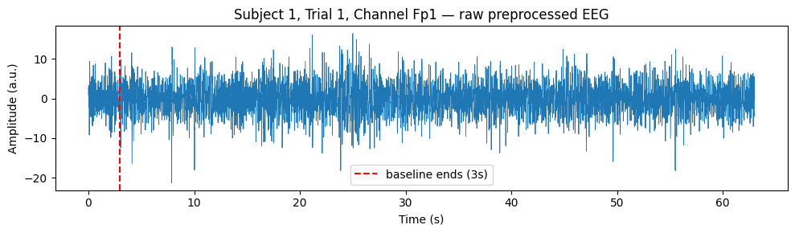
Figure 2. Example raw, pre-processed EEG trace for one channel (Fp1) of Subject 1, Trial 1. The dashed line marks the end of the 3-second pre-stimulus baseline, which is discarded before windowing.

3. Methodology

3.1 Feature Extraction
Following baseline removal, each trial's remaining 7,680 samples (60 s) were segmented into overlapping 4-second windows (512 samples) using a stride of 256 samples (50% overlap), which roughly doubles the number of training examples compared to non-overlapping windows. For each window, two parallel representations were computed:
- Raw branch: each channel's 512-sample segment was z-score normalized per channel (subtracting the window mean and dividing by the window standard deviation) to stabilize the input to the temporal encoder.
- Spectral branch: for each of the 32 channels, Welch's method was used to estimate the power spectral density, from which band power was integrated (via the trapezoidal rule) over five canonical EEG bands — theta (4–8 Hz), alpha (8–13 Hz), low-beta (13–20 Hz), high-beta (20–30 Hz), and gamma (30–45 Hz) — and log-transformed (log1p) to compress dynamic range.
Feature extraction was parallelized across all available CPU cores using Python's multiprocessing.Pool and cached to disk (deap_eeg_features_v2.npz) so that subsequent runs could skip recomputation. Applying this pipeline to all 32 subjects produced 37,120 windows in total, each represented as a (32-channel × 512-sample) raw tensor and a (32-channel × 5-band) spectral tensor. The window-level class balance mirrored the trial-level imbalance: 28,855 Low / 8,265 High for valence and 27,985 Low / 9,135 High for arousal.

3.2 Subject-Independent Train / Validation / Test Split
A critical design decision was to split the data by subject rather than by individual window. Because adjacent windows from the same trial (and the same subject) are highly correlated, a random window-level split would leak subject-specific signal characteristics between training and test sets and produce an overly optimistic performance estimate. To avoid this, scikit-learn's GroupShuffleSplit was used with subject identity as the grouping key: 20 subjects (23,200 windows) were assigned to training, 5 subjects (5,800 windows) to validation, and 7 subjects (8,120 windows) to a held-out test set, with disjointness between all three groups explicitly asserted in code. Normalization statistics (mean/standard deviation) for both the raw and spectral branches were computed on the training subjects only and then applied to the validation and test sets, preventing any information leakage through normalization.
Split | Windows | Subjects | Share
Train | 23,200 | 20 | 62.5%
Validation | 5,800 | 5 | 15.6%
Test | 8,120 | 7 | 21.9%
Table 1. Subject-independent data split used for training, model selection, and final evaluation.

3.3 Spatial Electrode Graph
To give the model a notion of electrode geometry, the 32 EEG channels were assigned approximate 2D scalp coordinates following the standard 10-20-style layout. Pairwise Euclidean distances between electrodes were converted into a Gaussian similarity (spatial prior) using a bandwidth equal to the standard deviation of all non-zero pairwise distances. From this similarity matrix, a k-nearest-neighbour graph (k = 5) was built, yielding a static prior graph with 160 directed edges connecting each electrode to its five closest spatial neighbours. This prior graph is not used as a fixed structure but as a bias term that regularizes the dynamic graph the model learns at run time (Section 3.4).

3.4 Model Architecture: TEDSTGT
The core model, TEDSTGT (Time-Efficient Dynamic Spatial-Temporal Graph Transformer), was designed to retain the key ideas of spatial-temporal graph transformers used in EEG literature — dual-domain features, a dynamic functional-connectivity graph, spatial priors, and electrode-level attention — while replacing the most expensive component of such models (full self-attention over long temporal sequences and over the electrode graph) with lighter convolutional and graph-convolutional operations. This keeps the parameter count and inference cost low. The architecture consists of six stages:

3.4.1 Per-Channel Temporal Encoder
Each channel's 512-sample raw window is passed independently through a small depthwise 1D CNN: three Conv1d→BatchNorm→GELU blocks (channel widths 8 → 16 → 32, strides of 4 each, progressively downsampling the sequence), followed by adaptive average pooling and a linear projection (with dropout and layer normalization) to a 64-dimensional embedding per electrode. Because the same small network is applied to all 32 channels independently (by folding channels into the batch dimension), the parameter count stays low regardless of the number of electrodes.

3.4.2 Spectral Encoder
The five band-power values per channel are passed through a two-layer MLP (5 → 32 → 64) with GELU activation, dropout, and layer normalization, producing a second 64-dimensional embedding per electrode.

3.4.3 Fusion
The temporal and spectral embeddings for each electrode are concatenated (128-d) and projected back to 64 dimensions via a linear→GELU→dropout→layer-norm block, giving a single fused per-electrode representation that carries both time-domain and frequency-domain information.

3.4.4 Dynamic Sparse Graph Construction
A lightweight attention-style mechanism computes low-dimensional query and key vectors (16-d) for every electrode from its fused embedding, and their dot products form a raw affinity score between every pair of electrodes. This score is symmetrized, biased by the log of the static spatial prior from Section 3.3 (scaled by a learnable spatial_bias term, set to 0.3), and masked on the diagonal to exclude self-loops. Only the top-k (k = 6) strongest edges per electrode are retained (top-k sparsification), and edge weights are squashed through a sigmoid before being symmetrized again. The result is a per-sample, per-window dynamic graph that combines the network's learned functional connectivity with a fixed anatomical prior.

3.4.5 Graph Message Passing
Two stacked graph layers propagate information along the dynamic graph: each layer computes degree-normalized neighbour aggregation of a linearly transformed message, concatenates it with the electrode's own state, and passes the result through a linear→GELU→dropout→layer-norm update block with a residual connection. Stacking two such layers lets information travel two hops across the electrode graph before pooling.

3.4.6 Electrode Attention Pooling and Classification Heads
A learned attention mechanism (a small MLP scoring each electrode, followed by a softmax over the 32 electrodes) produces a single graph-level embedding as a weighted sum of electrode states — this both aggregates information and yields an interpretable importance weight per electrode. This pooled vector passes through a shared linear→GELU→dropout→layer-norm block and then into two independent linear heads that output 2-class logits for valence and arousal respectively, allowing the two tasks to share the learned representation while making independent decisions.
Hyperparameter | Value
Embedding dimension (d_model) | 64
Dynamic graph key/query dimension | 16
Top-k edges per electrode | 6
Spatial bias weight | 0.3
Number of graph message-passing layers | 2
Dropout | 0.2
Trainable parameters | 49,366
Table 2. TEDSTGT architecture hyperparameters and resulting parameter count.

3.5 Training Configuration
The model was trained to jointly minimize the sum of two cross-entropy losses (valence and arousal), each using label smoothing (0.05) and softened inverse-frequency class weights. Rather than using full inverse-frequency weighting — which would push the model to maximize balanced accuracy at the cost of overall accuracy on this imbalanced (≈78/22) problem — a square-root-softened weighting scheme (softness = 0.5) was used, intended to discourage the model from collapsing entirely onto the majority class while still letting it exploit the class prior. As discussed in Section 5, this softening was not sufficient to prevent the collapse in practice. Optimization used AdamW (learning rate 1e-3, weight decay 5e-4) with gradient-norm clipping at 1.0 and a ReduceLROnPlateau scheduler (monitoring mean validation accuracy, halving the learning rate after 2 non-improving epochs). Automatic mixed precision (AMP) was implemented for GPU runs, but the training run reported in this document executed on CPU. Model checkpointing selected the epoch with the highest mean validation accuracy across both tasks, with an early-stopping patience of 5 epochs; the run itself was capped at 3 epochs (MAX_EPOCHS = 3), a constraint discussed further in Section 5 and Section 6.
Setting | Value
Optimizer | AdamW (lr = 1e-3, weight decay = 5e-4)
Loss | Sum of class-weighted, label-smoothed cross-entropy (valence + arousal)
Class weighting | Softened inverse-frequency (softness = 0.5)
LR scheduler | ReduceLROnPlateau (factor 0.5, patience 2, mode max)
Gradient clipping | Max norm 1.0
Batch size | 128 (train) / 256 (val, test)
Max epochs / patience | 3 / 5 (early stopping never triggered)
Checkpoint selection | Highest mean(valence acc, arousal acc) on validation set
Table 3. Training configuration.

4. Results

4.1 Training Dynamics
Table 4 summarizes the three training epochs that were run. Validation mean accuracy peaked at the very first epoch (77.5%) and did not improve in the following two epochs, at which point the run was stopped because MAX_EPOCHS was reached (not because of early stopping, whose patience of 5 was never exhausted). The best checkpoint therefore corresponds to Epoch 1.
Epoch | Train Loss | Val Loss | Val Valence Acc. | Val Arousal Acc. | Val Mean Acc.
1 | 1.3313 | 1.3048 | 0.820 | 0.730 | 0.775 (best)
2 | 1.3135 | 1.3472 | 0.721 | 0.730 | 0.725
3 | 1.2979 | 1.3417 | 0.771 | 0.726 | 0.749
Table 4. Per-epoch training and validation metrics. Training loss decreases steadily while validation loss does not, and validation accuracy fluctuates without a clear upward trend, both signs of a run that had not yet converged within the 3-epoch budget.
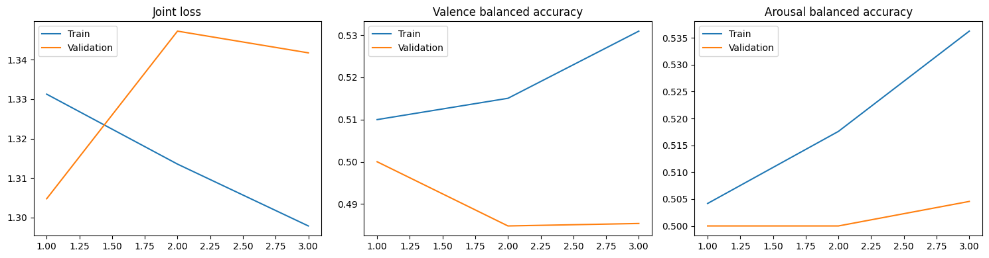
Figure 3. Joint training/validation loss (left) and per-task balanced accuracy (center: valence, right: arousal) across the three training epochs.

4.2 Test Set Performance
Final evaluation was performed once, on the fully held-out, subject-independent test set (7 subjects, 8,120 windows), using the Epoch-1 checkpoint selected on validation accuracy. Table 5 reports the full classification report for both tasks.
Task | Class | Precision | Recall | F1-score | Support
Valence | Low | 0.7645 | 0.9992 | 0.8662 | 6,206
Valence | High | 0.4444 | 0.0021 | 0.0042 | 1,914
Arousal | Low | 0.7429 | 1.0000 | 0.8525 | 6,032
Arousal | High | 0.0000 | 0.0000 | 0.0000 | 2,088
Table 5. Per-class precision, recall, and F1-score on the test set.
Metric | Valence | Arousal
Accuracy | 0.7642 | 0.7429
Macro-F1 | 0.4352 | 0.4262
ROC-AUC | 0.5850 | 0.5033
Table 6. Summary test-set metrics.
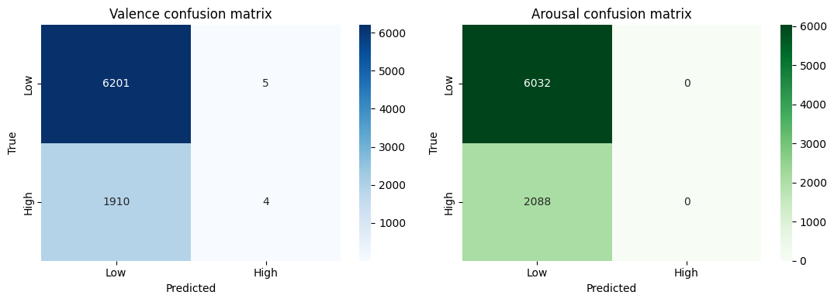
Figure 4. Confusion matrices on the test set. The model predicted “High” valence for only 9 of 8,120 windows and never predicted “High” arousal at all, effectively defaulting to the majority “Low” class for both tasks.

4.3 Interpretability: Learned Graph and Electrode Attention
For a single test example, the model's internal dynamic adjacency matrix and electrode attention weights were extracted and visualized (Figure 5). While the network does produce a non-trivial, spatially-structured connectivity pattern and a non-uniform electrode importance profile, the corresponding prediction on this example illustrates the majority-class bias identified above: the true label for this window was High valence / Low arousal, but the model predicted Low valence / Low arousal — correctly identifying arousal (which happened to be the majority class) but missing the true High-valence label.
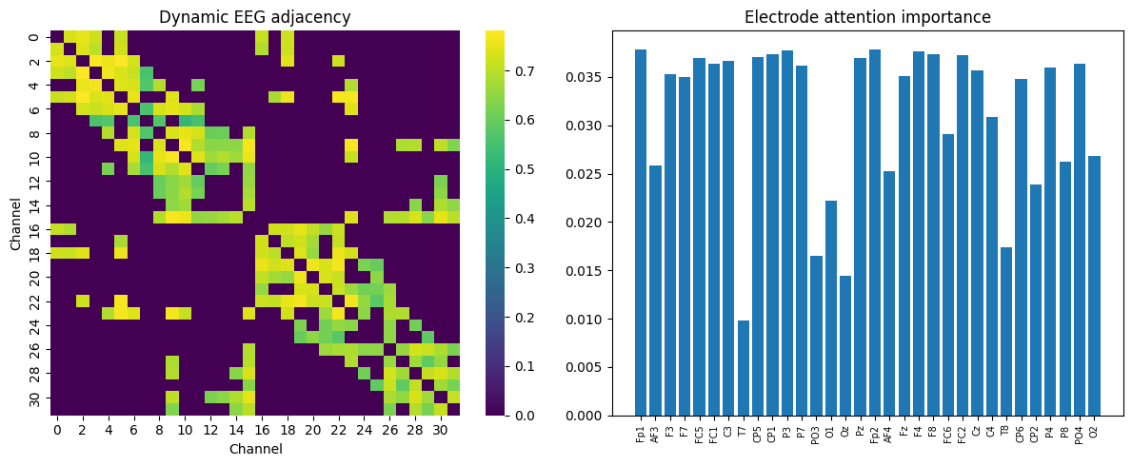
Figure 5. Left: dynamic electrode-to-electrode adjacency matrix learned by the graph module for one test window. Right: electrode attention (pooling) weights, showing which channels contributed most to the final pooled representation.

4.4 Computational Efficiency
One of the design goals was efficiency, and this was largely achieved: the model has only 49,366 trainable parameters, and a full forward pass over a batch of 256 windows took approximately 224 ms on CPU (roughly 0.876 ms per sample), which would be well within real-time requirements for practical deployment, especially on GPU hardware. The trained weights and normalization statistics were serialized to Group9_Dataset3_D_STGT_best.pt for later reuse.
Metric | Value
Trainable parameters | 49,366
Avg. inference time / batch (256 samples, CPU) | 224.2 ms
Avg. inference time / sample | 0.876 ms
Table 7. Inference efficiency measurements.

5. Discussion
The headline accuracy numbers (76.4% for valence, 74.3% for arousal) look reasonable in isolation, but the fuller picture in Section 4.2 shows that the model is not yet performing meaningful emotion recognition. Both accuracies sit almost exactly at the proportion of the majority “Low” class in the test set (76.4% Low for valence, 74.3% Low for arousal, per Table 5's support counts), and the confusion matrices confirm that the model is, in practice, a majority-class predictor: it recalls 99.9–100% of “Low” windows but only 0.2% (valence) or 0% (arousal) of “High” windows. The macro-F1 scores (0.435 and 0.426, versus a ceiling of 1.0 and a naive-majority baseline of roughly 0.43 and 0.42) and, most tellingly, the ROC-AUC scores (0.585 and 0.503) make this explicit: a ROC-AUC of 0.50 is equivalent to random guessing, so the arousal head in particular has learned essentially no usable signal for separating the two classes, despite achieving 74% raw accuracy.
Several interacting factors plausibly contributed to this outcome:
- Severe class imbalance (≈78/22): although softened inverse-frequency weighting and label smoothing were applied specifically to counter this, the softening (exponent 0.5) may have been too weak, or the class-weighted loss may need to be combined with resampling (oversampling the minority class, or a focal loss) to meaningfully shift the decision boundary.
- Very short training budget: the run was capped at 3 epochs, and the best validation score was obtained at Epoch 1, with training loss still decreasing at Epoch 3 while validation loss plateaued/increased slightly — a pattern more consistent with an under-trained model than a converged one. A longer run with a genuine early-stopping criterion (rather than a hard epoch cap) is needed before drawing firm conclusions about the architecture's ceiling.
- Subject-independent generalization is intrinsically hard for EEG affect labels: emotional and neural responses to the same stimulus vary considerably across individuals, and self-reported valence/arousal ratings are themselves noisy. It is well documented in the EEG-emotion literature that subject-independent (cross-subject) evaluation yields substantially lower performance than subject-dependent (within-subject) evaluation, and the results here are broadly consistent with that expectation.
- Model capacity and optimization interaction: replacing full self-attention with lightweight CNN/graph blocks (a deliberate efficiency choice, Section 3.4) reduces the parameter count to under 50k, which may simply be insufficient capacity to extract a robust cross-subject valence/arousal signal from 4-second windows within only 3 epochs of training.
Taken together, the honest interpretation of these results is that the pipeline, data handling, and architecture are technically sound and the leakage-avoidance measures (subject-level splitting, train-only normalization) are correctly implemented, but the trained model itself has not yet learned to discriminate high vs. low affect beyond the class prior. This is a common and instructive failure mode in imbalanced classification problems and is reported transparently here rather than papered over by citing the accuracy numbers alone.

6. Limitations and Future Work
- Train for substantially more epochs with true early stopping (not a hard cap), and monitor macro-F1 / balanced accuracy — not raw accuracy — as the model-selection criterion, since raw accuracy is misleading under this class imbalance.
- Address class imbalance more aggressively: try full (unsoftened) inverse-frequency weighting, focal loss, minority-class oversampling (e.g. SMOTE on features or window-level resampling), or a decision-threshold adjustment on the validation set rather than the default 0.5 cutoff.
- Expand hyperparameter exploration (top-k, spatial bias weight, number of graph layers, d_model) now that a working end-to-end pipeline exists, ideally with cross-validation across different subject folds to obtain a variance estimate rather than a single train/val/test split.
- Investigate subject-adaptive or subject-conditioned variants (e.g. lightweight per-subject calibration layers, or domain-adaptation techniques) given the well-known difficulty of cross-subject EEG affect transfer.
- Consider longer temporal context (e.g. attending across multiple consecutive windows within a trial) since single 4-second windows may not capture slower-varying affective state.
- Resolve the checkpoint-reload issue encountered in the final cell: PyTorch 2.6 changed torch.load's weights_only default to True, which rejects the NumPy objects embedded in this checkpoint; loading should either explicitly pass weights_only=False for this trusted, self-generated file or register the required globals via torch.serialization.add_safe_globals.
- Report confidence intervals or repeated runs (different random seeds / different subject-fold assignments) before drawing conclusions about the architecture, since a single 3-epoch run on a single split is not sufficient to separate genuine architectural limitations from an unlucky or under-trained run.

7. Conclusion
This project implemented a complete, leakage-safe pipeline for EEG-based binary valence and arousal recognition on the DEAP dataset, culminating in a novel, lightweight dual-domain graph-based architecture (TEDSTGT) that combines raw and spectral EEG representations with a dynamic, spatially-biased electrode graph and interpretable attention pooling. The engineering aspects of the project — subject-independent splitting, train-only normalization, parallelized feature extraction with caching, and an efficient 49k-parameter model capable of sub-millisecond inference — were implemented correctly and are reusable for future iterations. The current trained model, however, achieves its 74–76% test accuracy primarily by defaulting toward the majority “Low” class rather than through genuine valence/arousal discrimination, as evidenced by near-chance ROC-AUC scores. This is best understood not as a failure of the overall approach but as an expected outcome of a severely imbalanced, subject-independent EEG affect task trained for only three epochs, and Section 6 lays out concrete, prioritized next steps — principally longer training with F1/AUC-based model selection and stronger imbalance handling — to close this gap in future work.

